Henne
104 West Ave
Hicksville, NY 11801
516-931-7072 (home)
845-258-0903 (cell)
e-mail: wphenne@optonline.net

By way of introduction, I am an experienced insurance professional seeking to return to the industry. As the attached resume shows, I have a broad background in underwriting, marketing, industry relations, and technology. Having worked for insurers, a consulting company, two major industry organizations, and a large international broker, I believe my background is distinctive.

My work with ACORD allowed me to focus on insurer operations and the relationships between insurers, producers, and regulators. I left ACORD in 1995 and joined the staff at ISO where I played a major role in the publication of their study on Electronic Commerce.
I took a position with Frontier Insurance, where I managed the State Filings and Underwriting Support Department for a major writer of Program Business. Unfortunately, it was just before the downgrade by A.M. Best and the beginning of Frontier’s decline. I was with the company for nearly seven years, but most of that time was spent through its hardships as well as during the early efforts toward its rehabilitation under the guidance of the New York State Insurance Department. This was invaluable, not only in having worked side-by-side with regulators but was a unique learning experience as I witnessed first-hand the problems that an insurance company can encounter.

I joined Maya, a new carrier, that was looking to expand its book of business. I soon learned that the company needed its infrastructure built before any new development could take place. I found myself helping create that infrastructure, while trying to develop a Business Plan. My efforts were further complicated as the company did not have necessary surplus to grow and I did not want to submit a business plan to the Insurance Department that did not accurately state the company’s current situation. It was time to move on.

Over the last several years, I have done some consulting, was involved with two start-up companies outside of the Property/Casualty industry, and helped develop a new department to oversee the insurer claims process for a state-funded Early Intervention program. However, I’ve come to the realization that it is time to return to what I know best.

I believe that my skill set and experience is very well suited to the position you are seeking to fill; I look forward to hearing from you.

Thank you.

Sincerely,
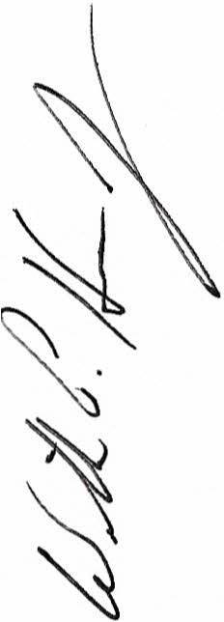
William P. Henne, Jr., CPCU, AIT

